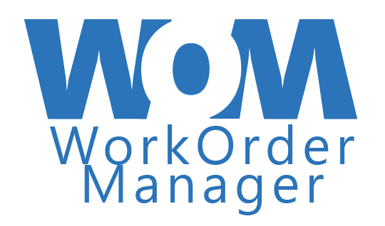

User Manual

**Instructor**

Achala Vinakota

**Project Team**

Rylan Cook

Maria Laura Diaz Pena

Trevor Erixon

Saeid Ghavamabadi

Jaehan Kim

Zennon Weleschuk

**August 16, 2021**

Contents

Preface 2

Purpose of Document 2

Documentation standards 2

System Overview 3

System Purpose 3

Clients 3

End-Users 3

Main Functions of the system 4

Installation Procedures 5

Reference Material 6

Login 6

Administrative User Screens 6

Work Center Super-User Screens 9

Regular User Screens 11

Miscellaneous 12

Logout 12

Tutorial 13

Administrative User 13

Work Center Super-User 16

Regular User 18

Miscellaneous 18

Index 19

# Preface

## Purpose of Document

This manual is intended for all users of the Work Order Manager application. It provides a detailed overview of all functionality within the application, broken down into role-specific instructions.

# System Overview

## System Purpose

Every organization expects that their assets and equipment will require maintenance. From routine repairs to unexpected damage and everything in between, things can happen to interrupt regular processes, but these interruptions cost the business money so minimizing downtime and maximizing knowledge capture is of utmost importance.

Designed with simplicity in mind, the Work Order Manager application will assist your organization with creation and assignment of work orders, while providing a convenient interface to your field-based employees that allows for an easy method to monitor for and complete assigned tasks with a few extra features to support their navigation to the job site and to account for the possibility of poor data connection while on the job.

## End-Users

There are defined roles within the system: Administrative user, Work Center super-user, and regular user.

An Administrative user may or may not be well-versed in the detailed knowledge of the business/work center, but they provide a valuable support role to the organization. It is anticipated that this user will typically be office-based and would typically access this application via desktop computer.

A Work Center super-user is typically a leader in the business, with specific detailed knowledge of the assets within their department and what/who would be required to fix them. They may split time between the office and the field so they would be expected to access the application both on a desktop or remotely on a tablet.

A Regular user will be field-based so will typically access the application remotely via tablet/handheld device to manage their tasks within work orders that they have been assigned to.

## Main Functions of the system

The application workflow begins with a notification that an asset or piece of equipment needs attention. An administrative user would take this information and enter it into the application to generate a formal notification that is then automatically sent in real-time to a super-user within the work centre that is responsible for the asset in question. This super-user can then take the information from the notification to generate a work order with more detail about what is required to correct the issue. Assignment of tasks/operations to specific users within the department can be done at any time, allowing the super-user to leverage the specific skillsets of their staff. Regular users will see their assignments upon accessing the application and can navigate to specific work orders to see the details of what they are required to do. Within a specific work order, any user will be able to access geolocation information to assist with locating and traveling to the job site.

Admin user

* Full summary visibility to all data within the application
* Notification creation
* New user creation
* Password reset
* Lock user account
* Delete functionality

Work Center super-user

* Full summary visibility to all data within their work center
* Work order creation from a notification
* Work order operation assignment
* Delete functionality

Regular user

* View all work orders to which they are assigned
* Change status and add comments to operations that are assigned to them
* Close work order and add final notes once all operations are complete

# Installation Procedures

No specific installation is required. Simply click on the following link and login with your credentials:

<http://workordermanagement-env.eba-b6f4e7q2.us-west-1.elasticbeanstalk.com/login>

Upon successful login, the user will be automatically directed to a web page specific to the role that their account is assigned. Each of these will be addressed in the documentation to follow.

No uninstallation is required.

# Reference Material

## Login

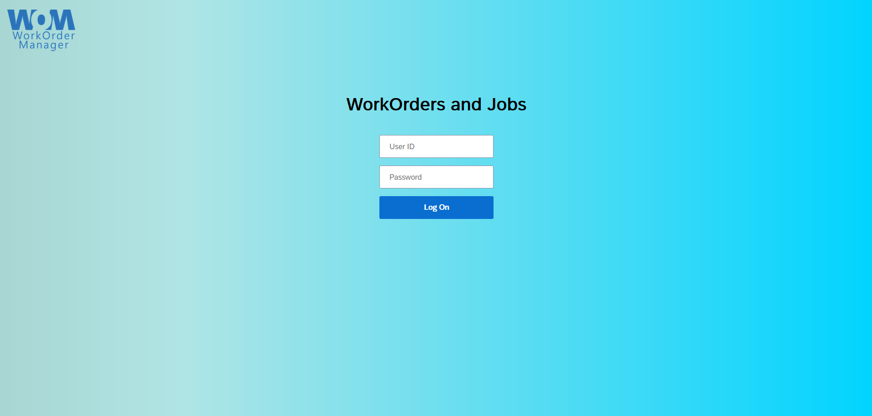

Figure 1 - Login screen

## Administrative User Screens

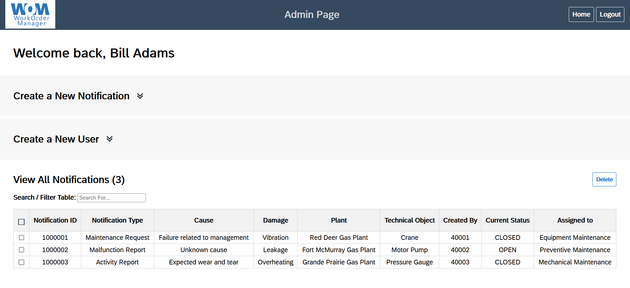

Figure 2 - Administrative landing page

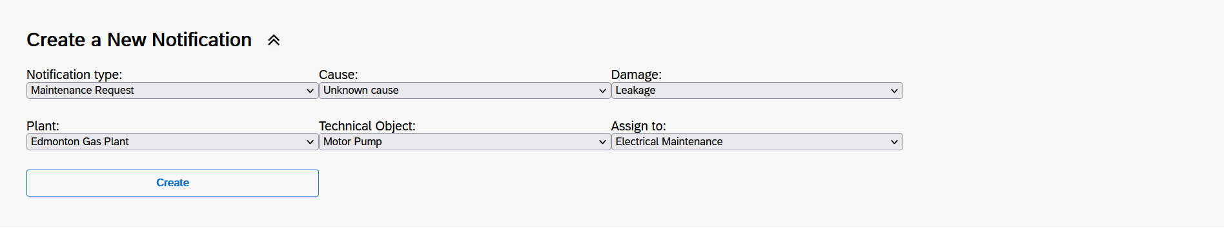

Figure 3 - Expanded 'Create a New Notification '

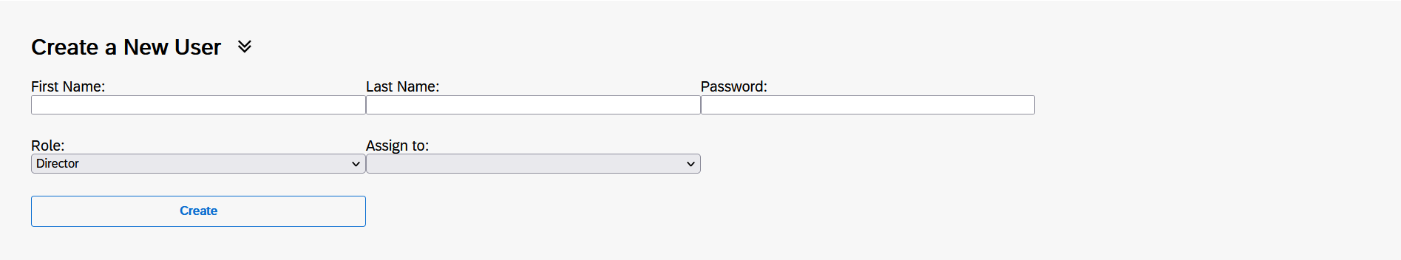

Figure 4 - Expanded 'Create a New User'

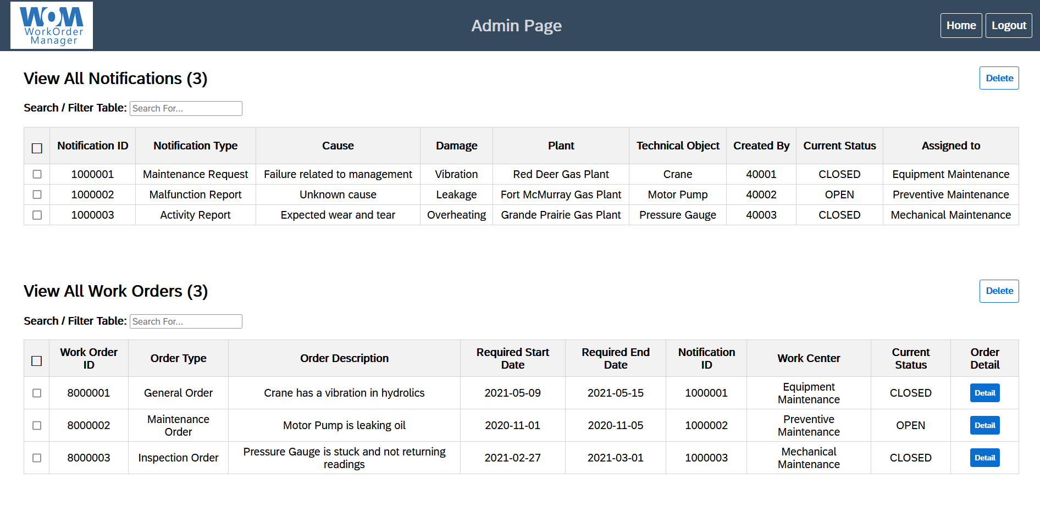

Figure 5 - Summary View of All Notifications and All Work Orders

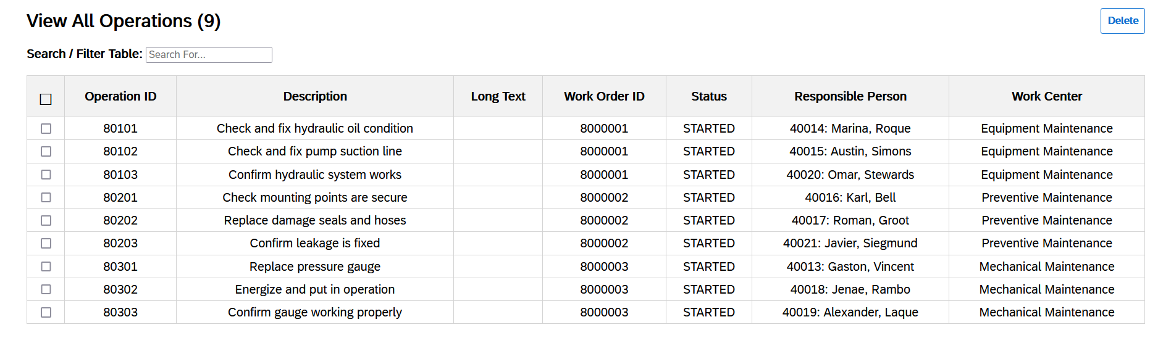

Figure 6 - Summary View of All Operations

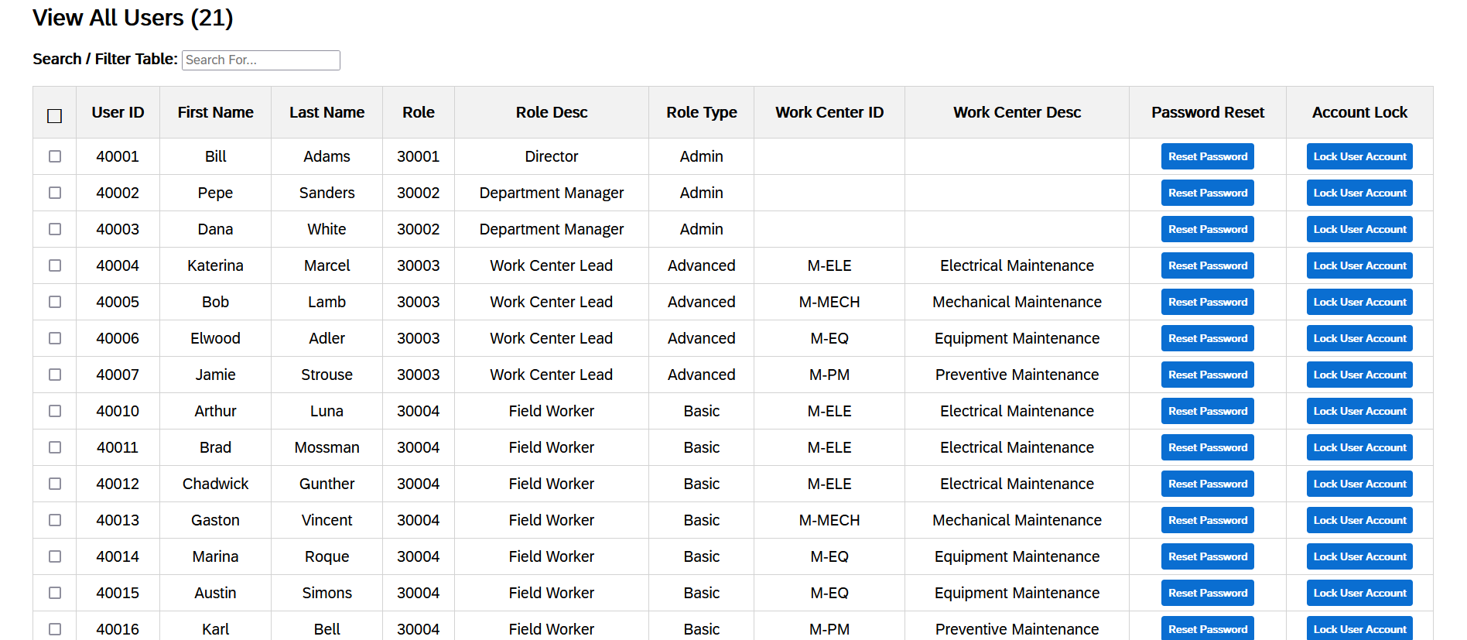

Figure 7 - Summary View of All Users

## Work Center Super-User Screens

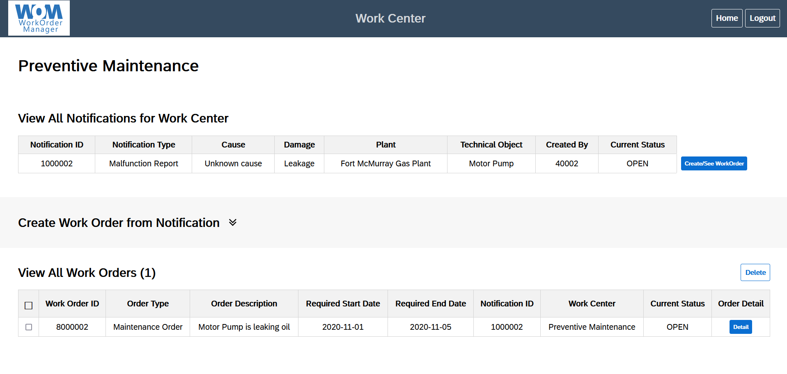

Figure 8 - Work Center Landing Page with Summary View of All Notifications

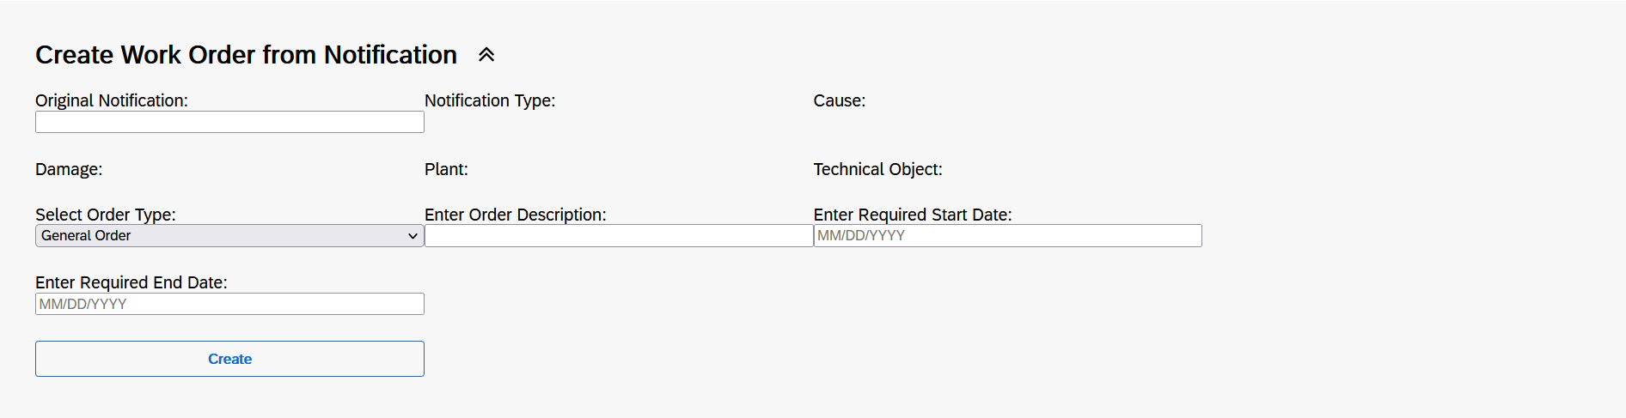

Figure 9 - Expanded 'Create Work Order from Notification'

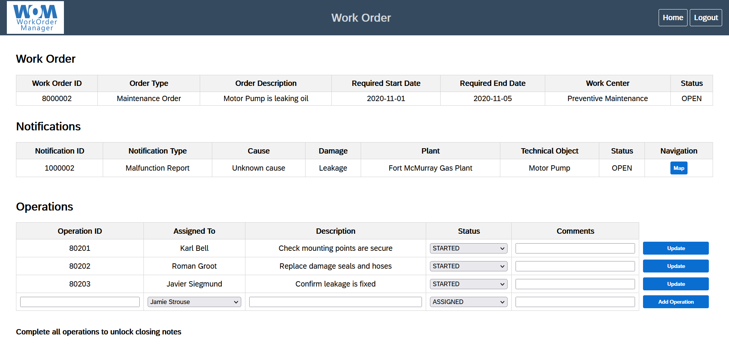

Figure 10 - Work Order Landing Page

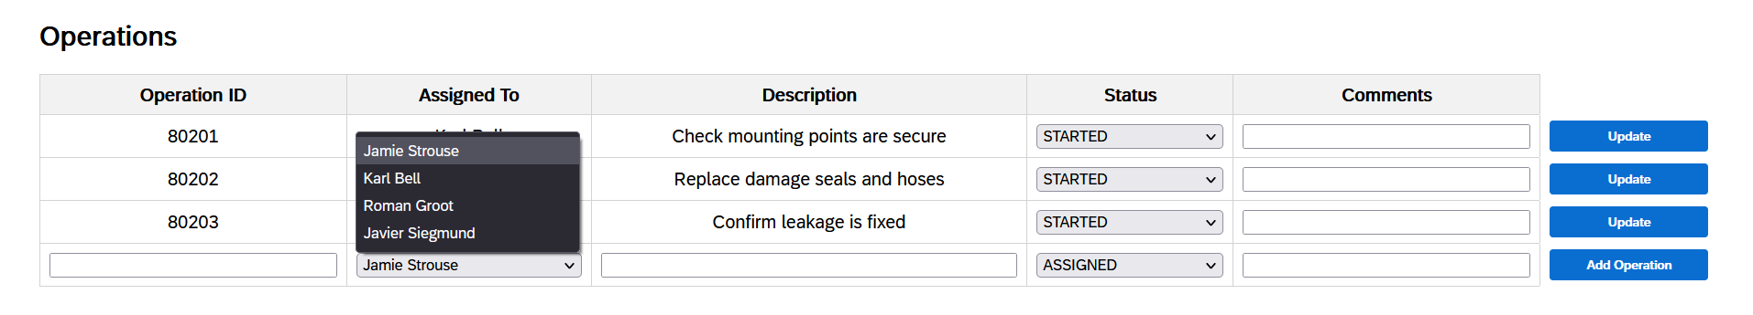

Figure 11 - Expanded 'Assigned To' Field for Assigning Operations

## Regular User Screens

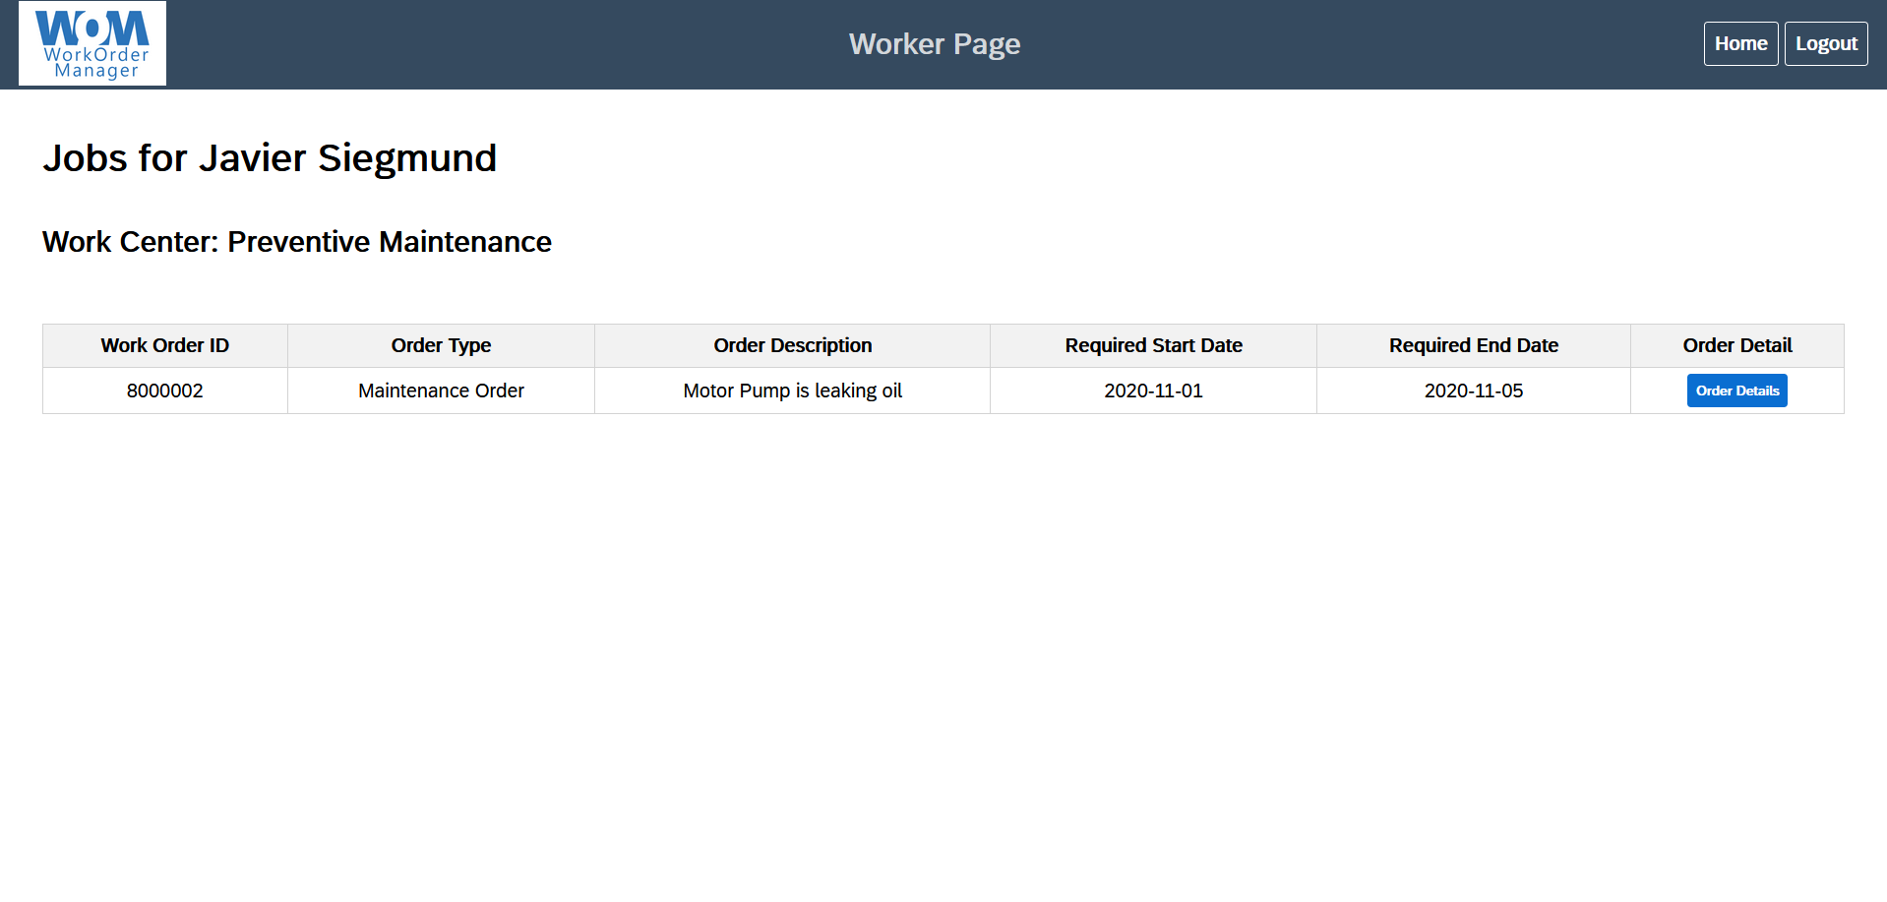

Figure 12 - Regular User Landing Page

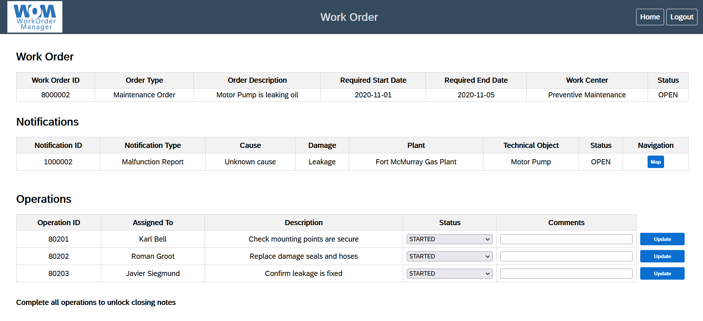

Figure 13 - Work Order Landing Page

## Miscellaneous

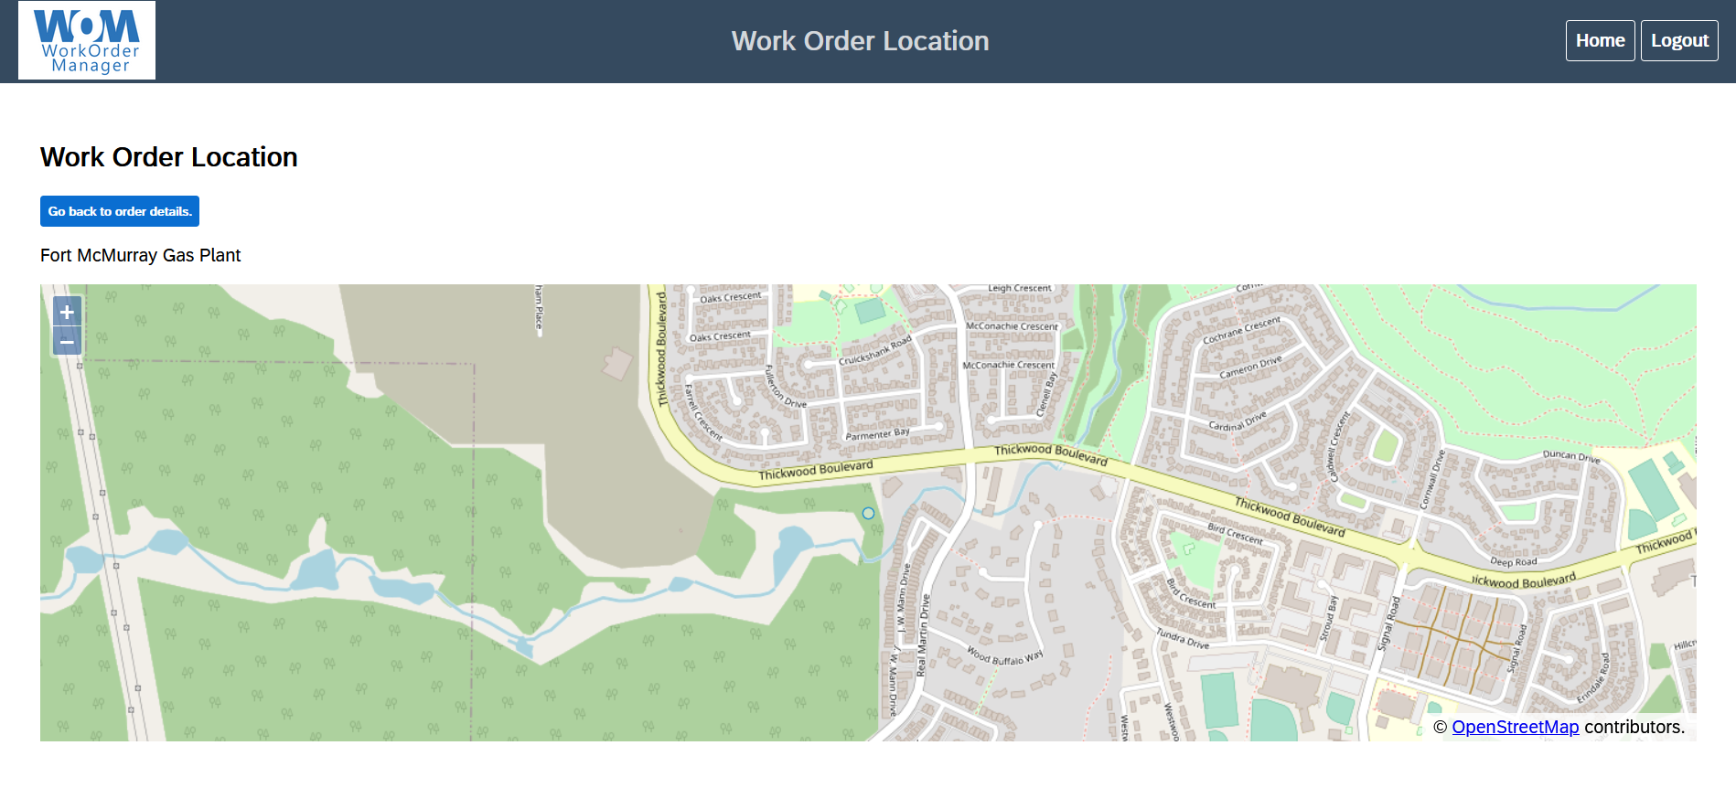

Figure 14 - Geolocation Page

## Logout

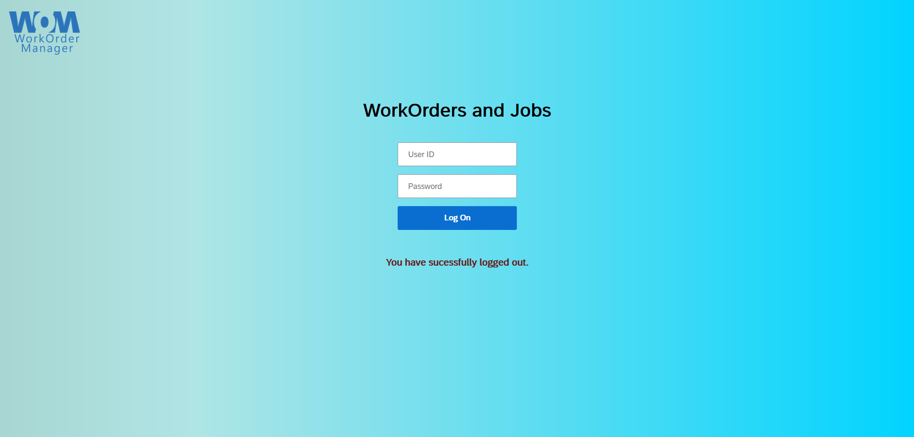

Figure 15 - Logout Screen

# Tutorial

## Administrative User

Administrative users have several specific functions available to their role:

1. Full summary visibility to all data within the application
2. Notification creation
3. New user creation
4. Password reset
5. Lock user account
6. Delete functionality
7. Full summary visibility to all data within the application

* Tables include all Notifications, Work Orders, assigned Operations, and Users
* Tables can be sorted/filtered for ease of access

1. Notification creation
   * Select the ‘Create a New Notification’ dropdown to expose required fields for completion.
   * Required fields:
     1. Notification type
        + Classification to provide some basic information about the request for repair/attention
     2. Cause
        + The cause of the damage
     3. Damage
        + The type of damage
     4. Plant
        + The plant location of the asset
     5. Technical object
        + The asset or equipment in need of attention
     6. Assign to
        + The work centre that will be notified
   * Each field has been designed as a drop down to aid in the speed of creation
   * To complete the notification creation, click on the ‘Create’ button
2. New user creation
   * Select the ‘Create a New User’ dropdown to expose required fields for completion
   * Required fields:
     1. First name
        + The new user’s first name
     2. Last name
        + The new user’s last name
     3. Initial password
        + The new user’s initial application password
     4. Role
        + The new user’s role
        + Current available selections: Director (Admin), Department Manager (Admin), Work Center Lead (Work Center super-user), Field Worker (Regular)
     5. Assign to:
        + The work centre that the user will be a member of
   * The name and password fields are all text-based; the remaining fields are dropdown menus
   * To complete the user creation, click on the ‘Create’ button
3. Password reset
   * Locate the user from the ‘View All Users’ table by scanning from top to bottom or by utilizing the sort/filter functionality at the top of the table
   * Select the checkbox that corresponds to the user requiring password reset and then select the ‘Reset Password’ button on the same line
   * The Users table will update to reflect that a forced password change has been initiated
   * Upon the user’s next attempt to login, they will be required to change their password to something different from their previous password
4. Lock user account
   * Locate the user from the ‘View All Users’ table by scanning from top to bottom or by utilizing the sort/filter functionality at the top of the table
   * Click on the ‘Lock User Account’ button at the end of the row corresponding to the desired user
   * Upon the user’s next attempt to login, they will be notified that the account is locked and to contact an admin
5. Delete functionality
   * Select one or more checkboxes from a single table to identify the records to be deleted
   * Click on the ‘Delete’ button in the upper right corner above the table
   * Each ‘Delete’ button corresponds to a specific table so it is not possible to delete a user and a notification with the same button click. To delete data from multiple tables, you must repeat these steps for each table

## Work Center Super-User

Work Center super-users have several specific functions available to their role:

1. Full summary visibility to all data within their work center
2. Work order creation from a notification
3. Work order operation assignment
4. Delete functionality
5. Full summary visibility to all data within their work center
   * Tables include all Notifications, Work Orders
   * Ability to view a specific notification or work order
6. Work order creation from a notification
   * Select a notification from the notification table. If it does not already have a corresponding work order, it will automatically populate the known fields of the ‘Create Work Order from Notification’ dropdown menu. Alternatively, you can manually enter the notification id number
   * Selecting a notification that already has a corresponding work order will take you directly into the work order
   * Required fields:
     1. Order Type
        + Additional classification to fine tune type of work order being requested
     2. Order Description
        + Additional details to provide regarding the general goal of the work order
     3. Required Start Date
        + In MM/DD/YYYY format
     4. Required End Date
        + In MM/DD/YYYY format
   * To complete the work order creation, click on the ‘Create’ button
7. Work order operation assignment
   * From the ‘View All Notifications’ table
     1. Click on the ‘Create/See Work Order’ button for any notification that already has a work order created
   * From the ‘View All Work Orders’ table
     1. Click on the ‘Detail’ button for the work order you wish to view
   * Once on the page for the desired work order, navigate to the ‘Operations’ table at the bottom of the page
   * Required fields:
     1. Operation ID
        + The next operation id number
     2. Assigned To
        + The field worker that is assigned to the operation
     3. Description
        + Detailed description of the specific task required to be completed
     4. Status
        + Current status of the operation
     5. Comments
        + Knowledge capture opportunity for the field worker handling the operation
   * To complete the operation assignment, click on the ‘Add Operation’ button
8. Delete functionality
   * Select one or more checkboxes from a single table to identify the records to be deleted
   * Click on the ‘Delete’ button in the upper right corner above the table
   * Each ‘Delete’ button corresponds to a table so it is not possible to delete a work order and a notification with the same button click. To delete data from multiple tables, you must repeat these steps for each table

## Regular User

Regular users have several specific functions available to their role:

1. Update operations
2. Update closing notes/close work order
3. Update operations
   * Required fields:
     1. Status
        + The current status of the operation
        + Changing operation status will change the notification/work order status to maintain consistency (i.e. if an operation is ‘paused’, the work order will also be paused)
     2. Comments
        + Knowledge capture opportunity for any status changes of the operation
   * Users can only make changes to operations that are assigned to them
4. Update closing notes/close work order
   * Once all operations have been addressed, the closing notes section of the work order will unlock and a large text box will appear
   * Required field:
     1. Closing Notes
        + Knowledge capture opportunity for summarizing any additional relevant details with respect to closing the work order
   * To complete the work order and set the status to closed, click on the ‘Update Work Order’ button

## Miscellaneous

Any user that is able to access a work order has the ability to see a map showing the location of the work order.

1. Click the ‘Map’ button found in the Navigation column of the Notification table

# Index

**Administrative User**

*Definition*, ***3***

*Functions of*, ***4***

*Screens*, ***6 – 8***

*Tutorial*, ***13 – 15***

*Delete,* ***15***

*Lock user account,* ***14 – 15***

*New user creation,* ***14***

*Notification creation,* ***13***

*Password Reset,* ***14***

**Installation Procedure**, ***5***

**Login**

*Screen,* ***6***

**Logout**

*Screen,* ***12***

**Miscellaneous**

*Geolocation Screen,* ***12***

*Tutorial,* ***18***

**Regular User**

*Definition,* ***3***

*Functions of,* ***4***

*Screens,* ***11***

*Tutorial,* ***18***

*Close work order,* ***18***

*Update operations,* ***18***

**System**

*Purpose,* ***3***

*Workflow,* ***4***

**Work Center Super-User**

*Definition,* ***3***

*Functions of,* ***4***

*Screens,* ***9 – 10***

*Tutorial,* ***16 – 17***

*Create work order from notification,* ***16***

*Delete,* ***17***

*Work order operation assignment,* ***16 – 17***